Notes: **Assignment 1 is not submitted separately, but those corrections get graded via Assignment 2 (so no need to submit two versions)**

- The App is being **built only for GTA’s and the Network Admin in mind**, so some of the stuff written about possible features for the students (tutorials, etc) would be removed from user requirements.

**Use Case Diagram:** (Tutorial on icollege: [Week4](https://gastate.view.usg.edu/d2l/le/content/1990416/Home?itemIdentifier=D2L.LE.Content.ContentObject.ModuleCO-34574732) > IN Class Activity > Use Case Diagrams)

Mussa Feedback: **Break down use cases into Verb-action pairings.**

Ex: “Ensure Enough Inventory” ⇒ **“Check Inventory”**

“Form 2 By TA” => **“Check-in Equipment”** (with GTA pointing to the use case)

* Add roster / update roster, add gta/remove gta
* Use Extend, Generalizations, and more (where needed)

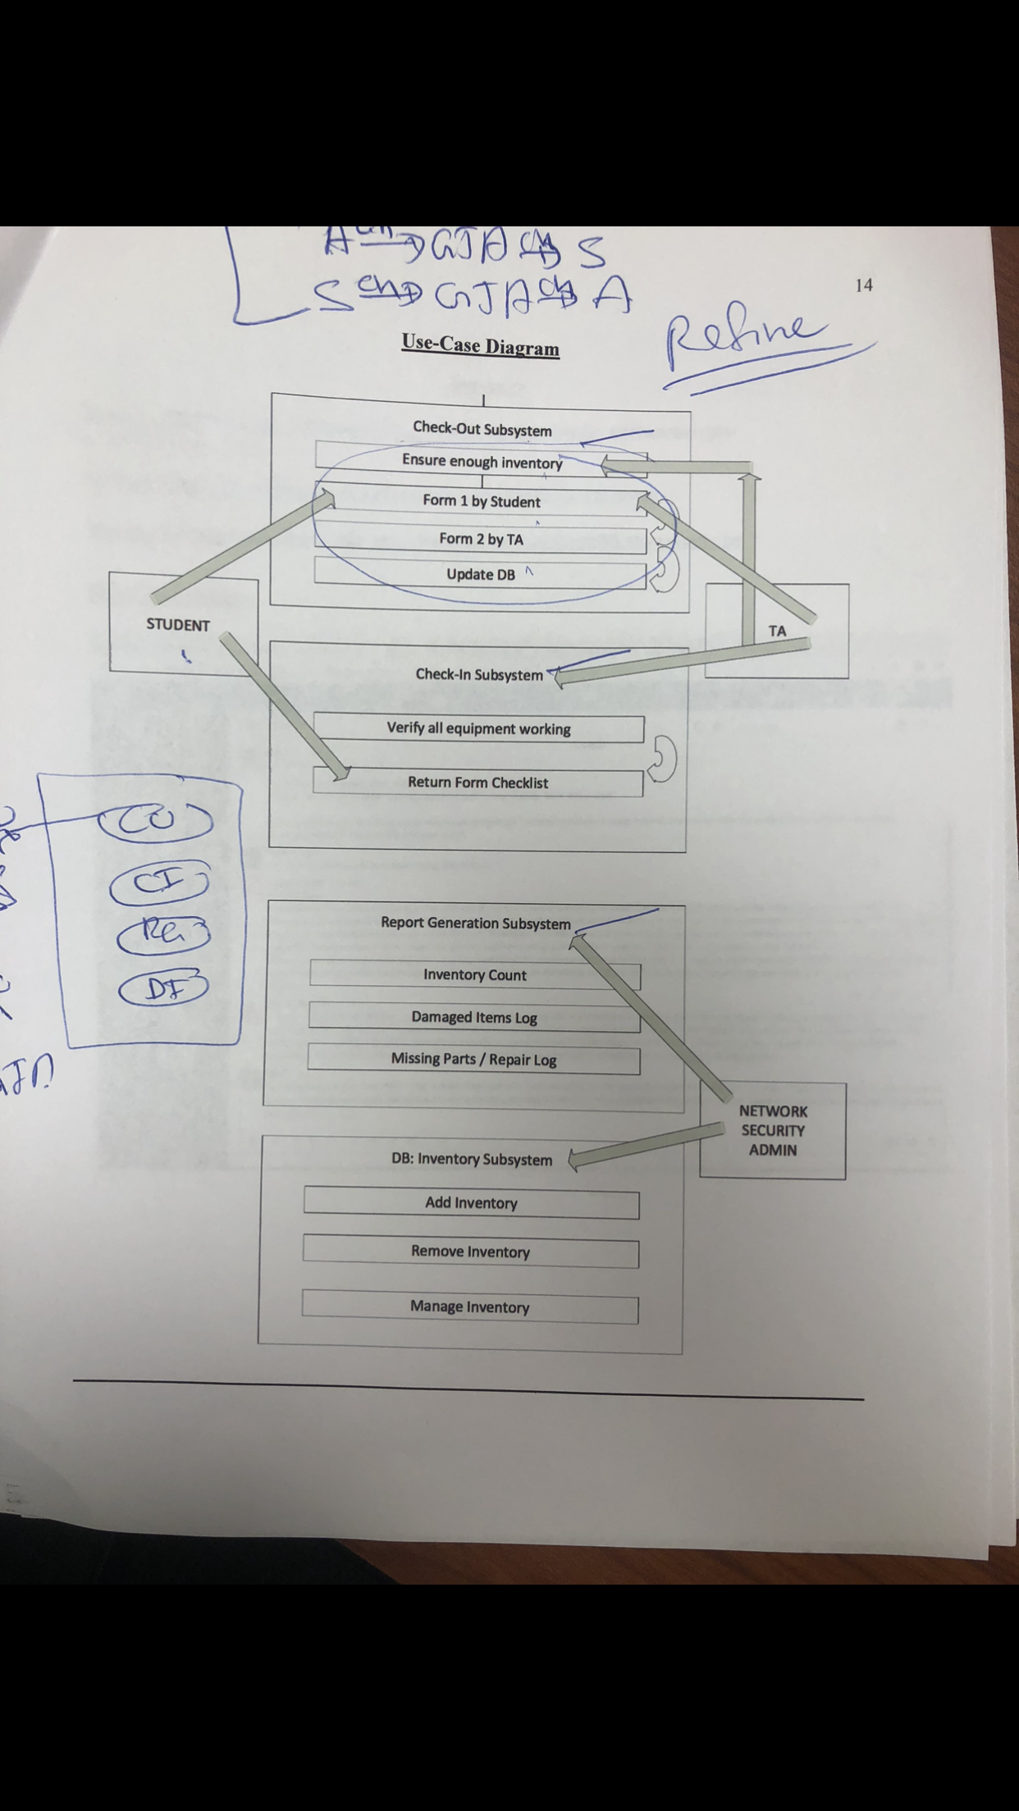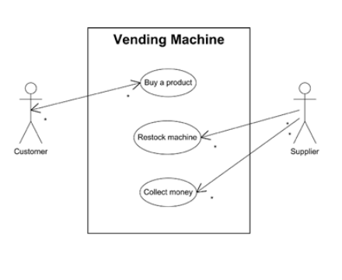

===============================================================

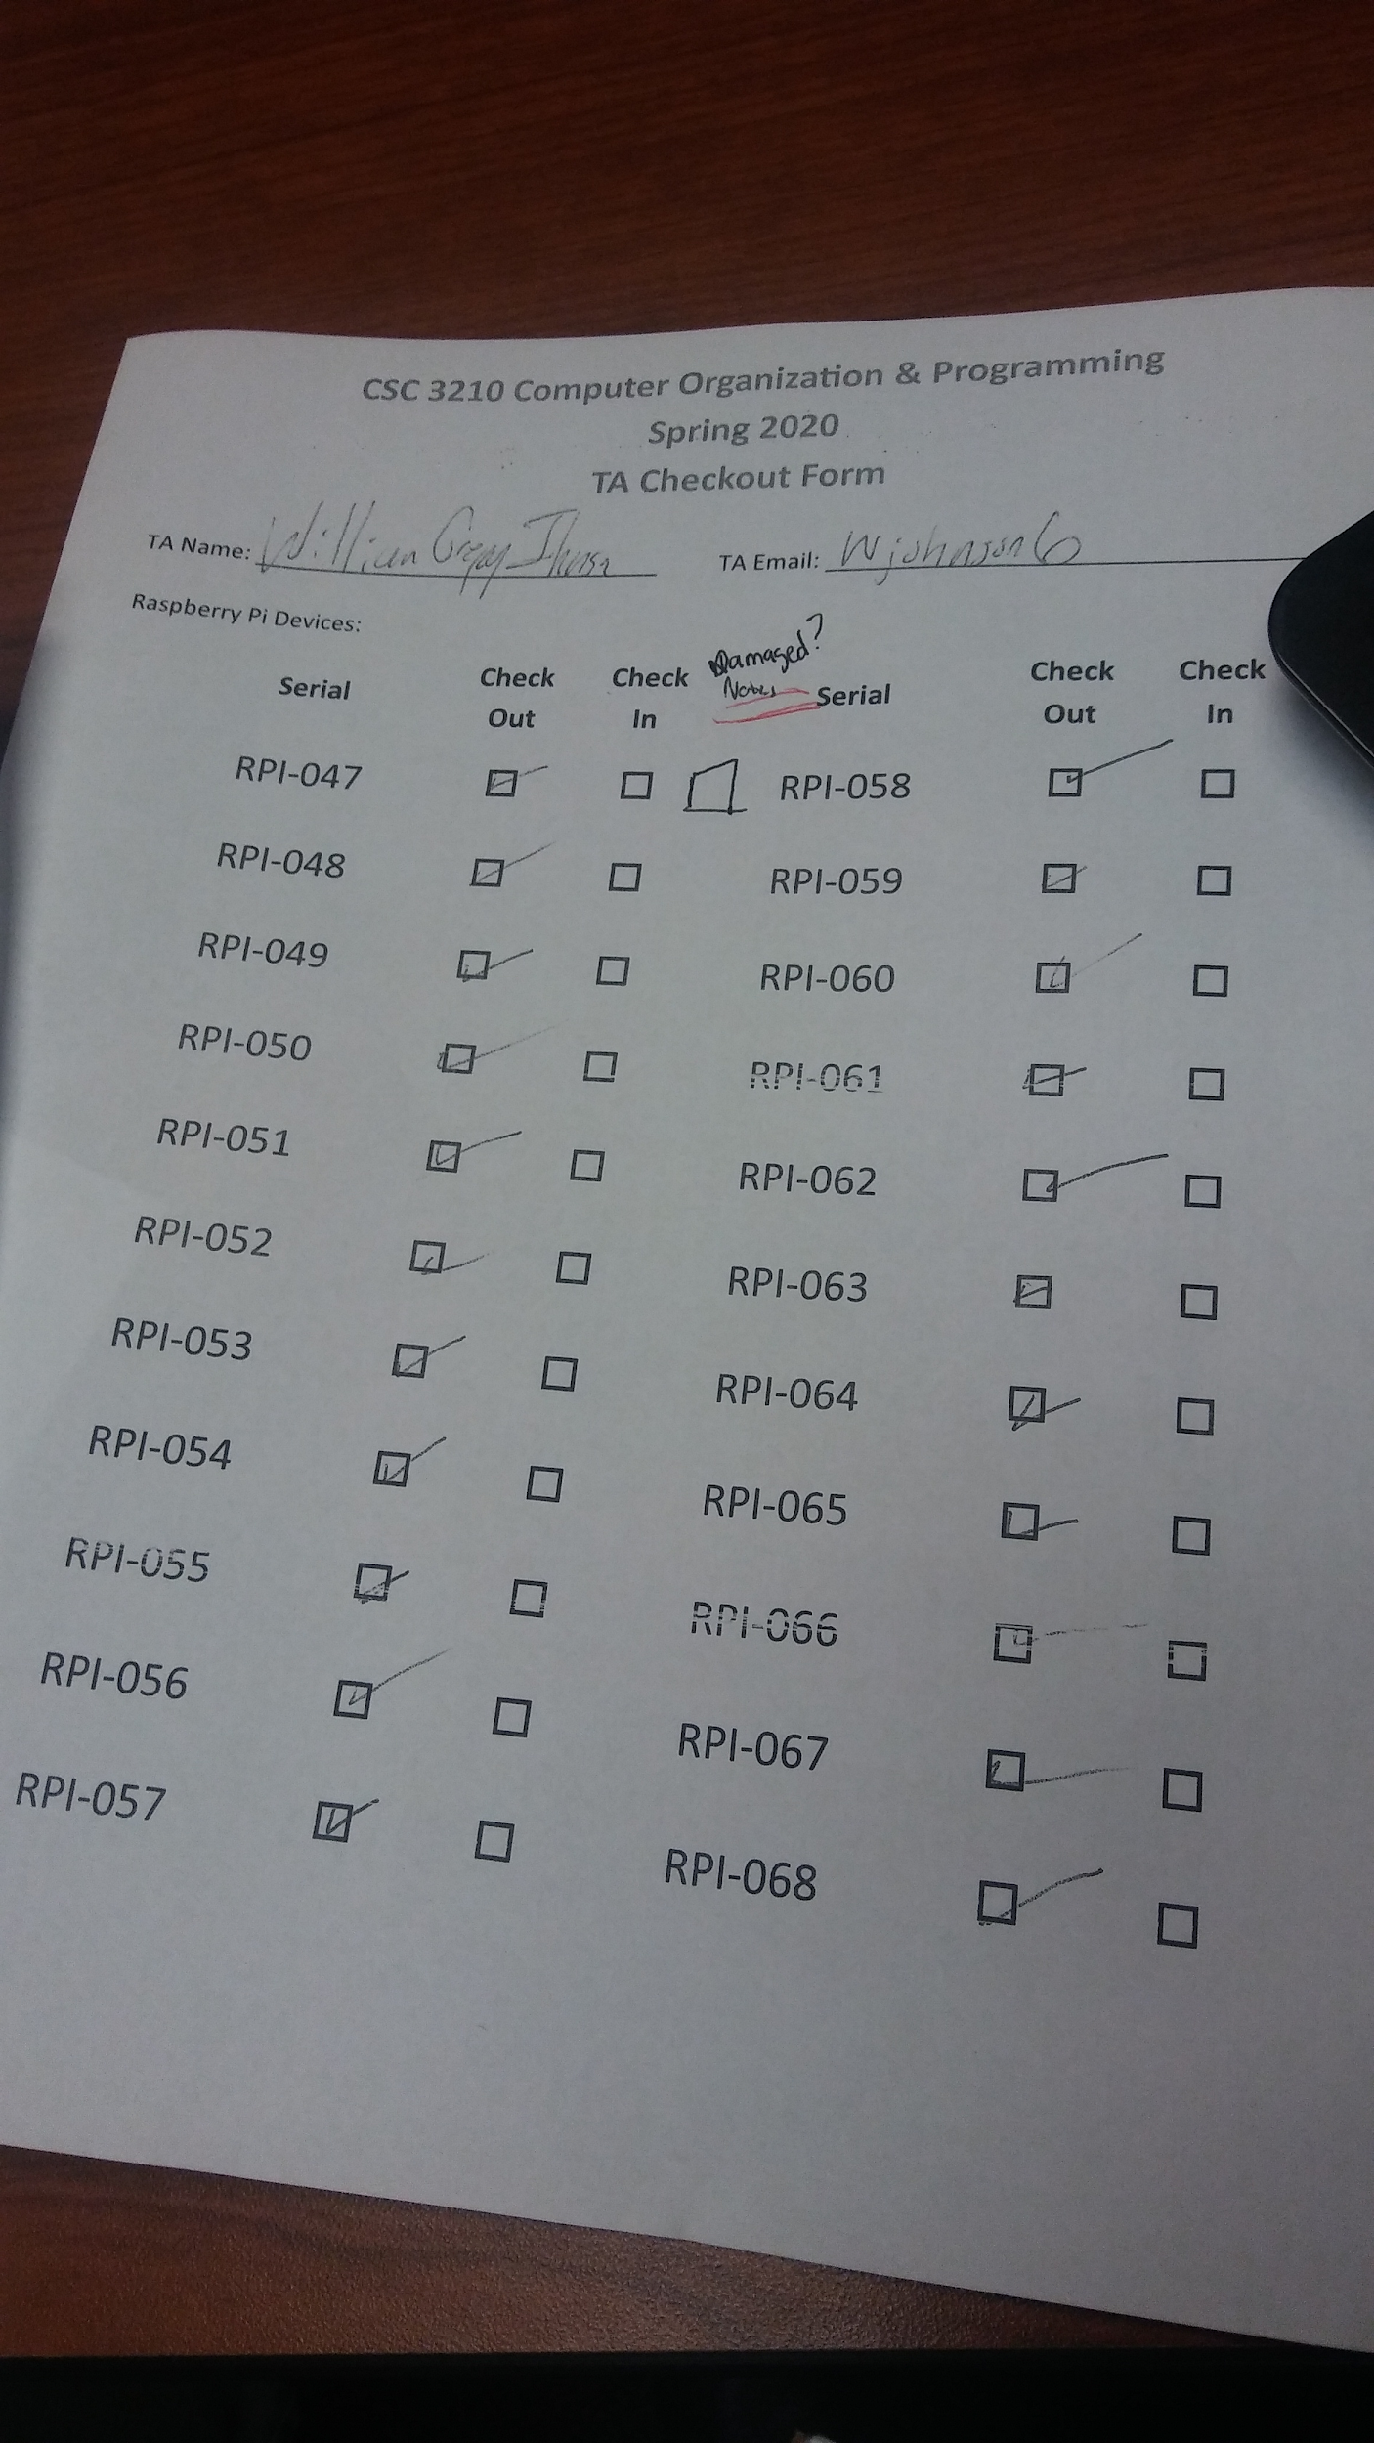

**Form 2: TA Checkout Form**

**Notes: There should be a section for them to checkmark if the Raspberry Pi is damaged.**

* **If this is checked, it enables a required dropdown list to allow the TA quickly select a reason why it is damaged.**
* **Each New checkin should store the date, time and the name of the student TA that checked it in.**

**System Actors:**

* **Dr Mussa? (“Instructors”)**
* **One network admin (“power user”)**
* **One level for basic TA’s to check and checkout RPIs.**

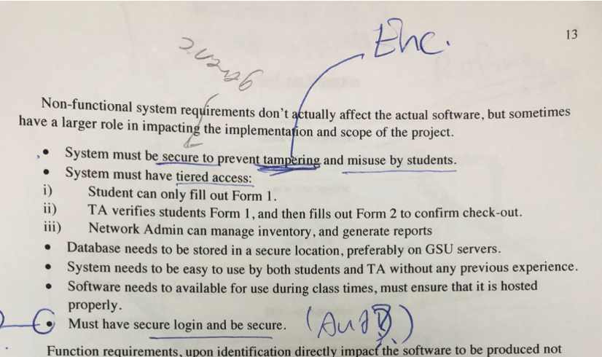

**Non Functional System Requirements:**

* **So to handle “secure to prevent tampering”, we can use encryption to send data via (HTTP Secure) and decryption on the server side.**
* **Matches key along with the file.**

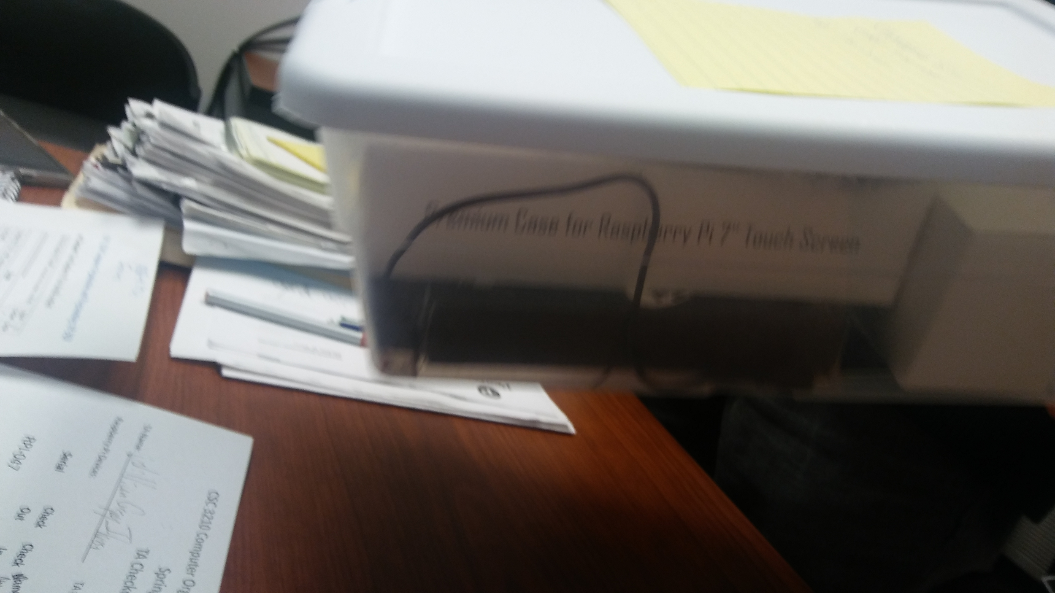

**Possible Edge Case:**

Students who withdraw from classes early (before the return deadline), leaving instructors or the TAs to return the set early.